WIKI-AM,C-Taino-Cemi-*Maquetaurie Guayaba*- Lord of the Dwelling Place of the Dead

According to Fray Pané, the Taino “believe there is a place where the dead go, which is called *Coaybay*, and it is located on one side of the island called *Soraya*. They say that the first person in *Coaybay* was one who was called *Maquetaurie Guayaba* [*Makitori-Guarana*], who was the lord of the said *Coayabay*, house and dwelling place of the dead (Pané, ch. 12, 1999: 17-18, italics added). José Juan Arrom suggests *Maquetaurie* may be translated “without life” (*ma,* signifying a negation, and *quetaurie*, signifying “life”) and *Guayaba* may be translated as “the fruit of the tropical tree *Psidium paniferum”* the juice of which was used to make black body paint which symbolized death (see Stahl 1899:226). The face of the first person in *Coaybay* was one who was called *Maquetaurie Guayaba*. Because he is the Lord of the dark recesses such as caves or of the dark forest he has wide[-open] eyes and a mouth usually without lips, and [a body with] no navel, which signified him being of the nether regions and death” (Arrom in Pané 1999: 18, n. 80, n. 81). The Taíno worshipped *cemi* spirits of their ancestors as well as *cemi* spirits of the Land of the Dead, of the sea, of rain, of fertility and of various important plants including cassava, their staple food, and of course *Guayaba*. Zemi figures were maintained in domicile shrines and given offerings of food and drink.

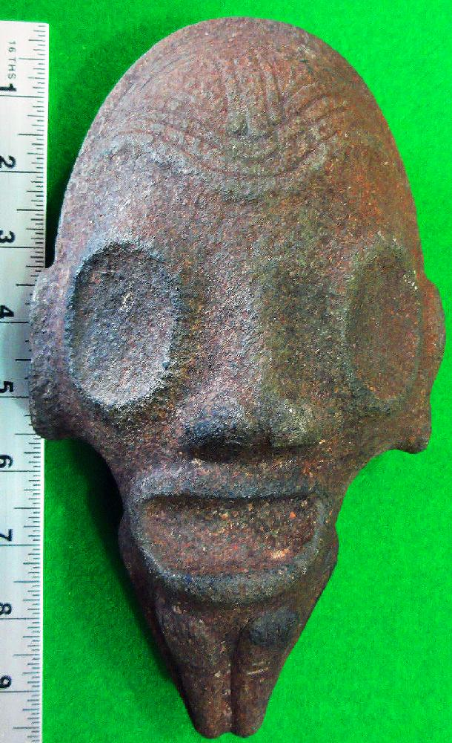 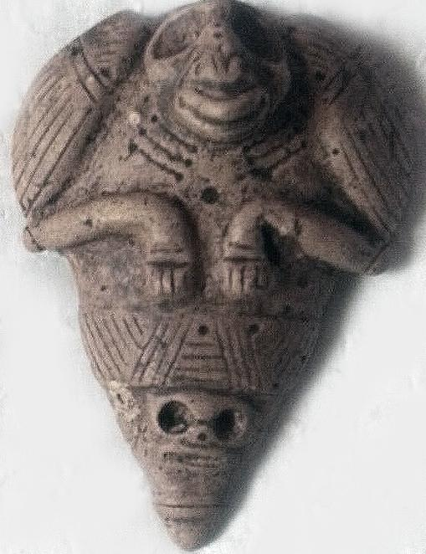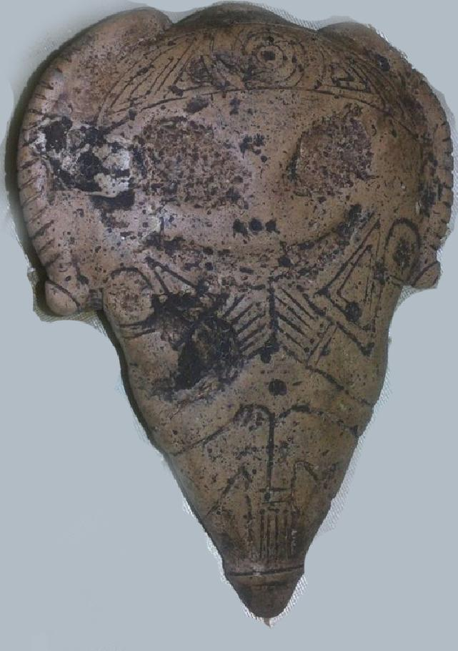

Anthropomorphic *cemi* (spirit) of *Maquetaurie Guayaba*, Lord of the Dwelling Place of the Dead, *Coaybay. Ca.* 900-1500 AD/CE, Taino period. Left: andesite stone, height 9.75 in. Center and right: marble, height 7 in.

The left-hand figure above shows *Maquetaurie Guayaba* with wide-open eyes and a mouth without lips, one of *Maquetaurie Guayaba’s* distinguishing features. The center and right-hand figures show a different conception of *Maquetaurie Guayaba.* In the center image *Maquetaurie Guayaba* is the skull mask at the bottom of the figure with hollow circular eyes and skeletal teeth (signifying death). A bird, probably a nocturnal bird, perhaps an owl, that has a clearly defined navel, which signifies that it is a bird of the living world, is transporting this figure. Owls were revered as the avian counterparts of the spirits of the dead with their haunting nocturnal calls. Consequently, Taínos were reluctant to travel into the forests at night as this was the owl’s realm and was also considered to be the realm of deceased ancestors. The right-hand (obverse) of the central image probably shows *Maquetaurie Guayaba* with an inviting countenance and both hands placed to the mouth as though having divulged a secret. This side of the figure is probably intended to be a body stamp used with the black juice of the fruit of the tropical tree *Psidium paniferum,* traces of which may still be adhering to its surface

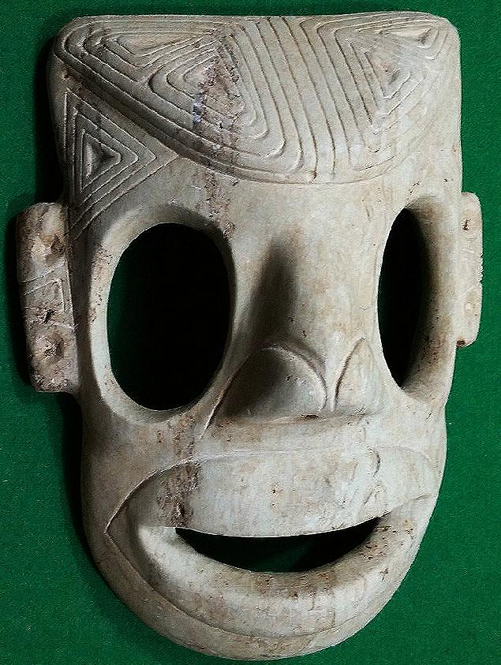

Anthropomorphic Mask: Length: 9 1/8 in., marble. Dominican Republic. 1200-1500 AD/CE.

This very rare, large mask carved from marble by a master sculptor probably shows *Maquetaurie Guayaba* again with an inviting countenance. The elaborately sculpted ears, the temples and the cranium are inscribed with a triangular motif that recalls the shape of the tri-pointed or three-pointed stone sculptures that evoke both the shape of the holy Taíno mountain, Cauta, and the shape of the mounds in which the Taíno grew their staple food, yucca. This mask might have been similar to the one used in the ceremony recounted by Columbus:

References

Pané, Fray Ramon. 1999. *An account of the antiquities of the Indians*. A new edition, with introductory study, notes, & appendices by José Juan Arrom. Translated by Susan C. Griswold. Durham and London: Duke University Press.

Stahl, Don Augustin. 1899. “The Fauna and Flora of Porto Rico”. In Elihu Root, *Collection of United States Documents*, (Washington: Government Printing Office) 222-230.